

TEST REPORT

Doc No: HTPL/FOR/ENGG/TR03
Ver: 1.2

DOCUMENT DETAILS

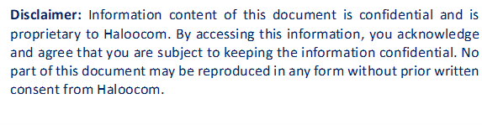

HTPL/FOR/ENGG/TR03

SOFTWARE TEST REPORT

OVERVIEW
Testing was completed by Sauravi and Naveen on June 23, 2025. Several issues were identified during the testing of the call-status filter functionality:
The objective was to implement and verify the call-status filter option for Mswipe Hexa Call-Log report, where users needed to filter call logs based on different call statuses (connected, Not_connected) with proper data accuracy and performance.

SOFTWARE IDENTIFICATION
- Name: Mswipe Hexa.
- Module Name: Call-Log Reporting & Analytics.
- Version: 1.2

TEST DATES & DURATION
- Test Start Date: June 23, 2025
- Test Completion Date: June 23, 2025
- Test Duration: 1 day
- Test Effort: 2 person-days

TEST RESOURCES
People Involved
- Test Lead: Sauravi
- Test Analyst: Naveen
- Development Lead: Nagendra
- Developer: Sauravi

ISSUES RAISED
Bug ID | Description | Severity | Status
BUG_001 | Call-log export functionality not respecting call-status filter selections. | Low | Open

BUGS FIXED
Bug ID | Description | Fix Details | Status
BUG_001 |  | Modified export logic to include call-status filter parameters. Ensured exported data matches filtered view displayed on screen. | ✅ Fixed
  Call-log export functionality not respecting call-status filter selections.

ADDITIONAL DETAILS
What Was Tested
- Data accuracy of filtered call-log reports across different call statuses.
- Filter combination with existing date-range and other filters.
- Export functionality with call-status filter applied.
Summary
- Issues Resolved: export functionality, and performance.
- Severity Range: Low
- Status: All issues resolved.
Workaround
- NA (Fixed in code directly)
Recommendation
Implement call-status filter presets (e.g., "Connected Calls", "Not Connected Calls") to improve user experience. Consider adding call-status analytics dashboard showing distribution of call statuses over time. Also recommend implementing filter state persistence to remember user's last selected call-status filters across sessions.
APPROVALS
Approver | Signature | Date

