

TEST REPORT

Doc No: HTPL/FOR/ENGG/TR04
Ver: 1.2

DOCUMENT DETAILS

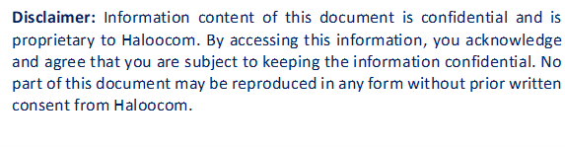

HTPL/FOR/ENGG/TR04

SOFTWARE TEST REPORT

OVERVIEW
Testing was completed by Sauravi and Naveen on June 30, 2025. Several issues were identified during the testing of the List ID deactivation script and restricted calls scheduling functionality:
The objective was to implement and verify the automated script for List ID deactivation after 7 PM and ensure pending restricted calls are properly scheduled to dial out the next day, with comprehensive logging capabilities for tracking and audit purposes.

SOFTWARE IDENTIFICATION
- Name: Mswipe Hexa.
- Module Name: List Module List ID deactivation script.
- Version: 1.2

TEST DATES & DURATION
- Test Start Date: June 30, 2025
- Test Completion Date: June 30, 2025
- Test Duration: 1 day
- Test Effort: 2 person-days

TEST RESOURCES
People Involved
- Test Lead: Sauravi
- Test Analyst: Naveen
- Development Lead: Nagendra
- Developer: Sauravi

ISSUES RAISED
Bug ID | Description | Severity | Status
BUG_001 | Restricted calls log entries missing timestamp information. | Low | Open

BUGS FIXED
Bug ID | Description | Fix Details | Status
BUG_001 |  | Enhanced logging module to include detailed timestamps (YYYY-MM-DD HH:MM:SS format), call ID, List ID, and action type in all log entries. | ✅ Fixed
  Restricted calls log entries missing timestamp information.

ADDITIONAL DETAILS
What Was Tested
- Automatic deactivation of active List IDs at 7:00 PM sharp.
- Verification of deactivation status in database.
Summary
- Issues Resolved: List deactivate issue.
- Severity Range: Low
- Status: All issues resolved.
Workaround
- NA (Fixed in code directly)
Recommendation
Implement real-time monitoring dashboard for script execution status.
APPROVALS
Approver | Signature | Date

